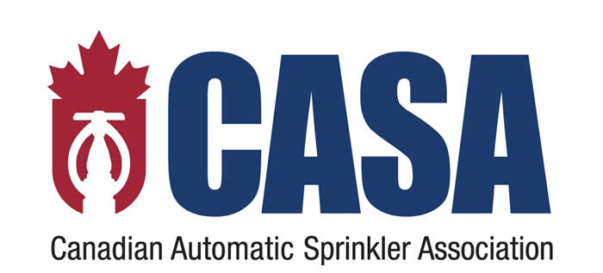

FIRE PROTECTION & SAFETY
Application form for CASA Members

Client Information
Company Name:
Contact Name:
Address:
Other Locations:
Phone: |  | Fax:
E-mail:

Description of Operations
Operations: | Sprinkler Contractor Alarm Contractor Both
Sprinkler & Alarm Contractors
Years in business: |  |  | # of employees:
% of Installation: | % |  |  | % of Service:
% of Design: | %
Do you require Proof of Liability from Subcontractors? |  |  |  |  | Yes No
What Limit of Liability do you require? |  |  |  | $1million $2million $3million
% of Sub-Let Work: |  |  | Design/Engineering: |  | Yes No
% of Installation Services: |  |  |  | Residential | %
 |  |  |  | Commercial | %
 |  |  |  | Industrial | %
Have you ever been declined, cancelled or non renewed  by an Insurance Company? |  |  |  |  | Yes No
Current Insurance company:
Have you had any Claims in the Past 3 Years?  If Yes, please attach details. |  |  |  |  | Yes No
Annual Gross Revenue: |  | $ |  | US Sales: | $
Alarm Contractors Only
Do you provide any Monitoring Services? |  |  |  |  | Yes No
% of Monitoring Services: |  |  |  | Residential | %
 |  |  |  | Commercial | %
 |  |  |  | Industrial | %
% of Operations: |  |  |  | Alarm Monitoring | %
 |  |  |  | Answering Services | %
 |  |  |  | Emergency 911 | %
 |  |  |  | (Attach copy of service contract)
 |  |  |  | Paging Services | %
Is your station ULC Listed? |  |  |  |  | Yes No
Is your Monitoring System Computerized? |  |  |  |  | Yes No
Do you have Back-up Power System in place? |  |  |  |  | Yes No
Do you require Employees to complete a Training Program? |  |  |  |  | Yes No
Do you conduct Background Checks for potential employees? |  |  |  |  | Yes No
Do you have written procedures for employees? |  |  |  |  | Yes No

General Liability
Limit required: | $1million | $2million |  | $3million
 | $5million | $10million
The Limits Selected Automatically Include:
1. Failure to Perform Tenants Legal  Liability  2. Non-Owned Automobile  3. Damage to Hired Automobiles |  | 4. Employers Liability  5. Employee Benefits Legal Liability  6. Employee Medical Expenses  7. Advertising Liability
Deductible | $2,500 | $5,000 |  | $10,000
Do you engage in any of the following?

Demolition  Shoring | Underpinning  Excavation |  | Use of Explosives  Welding

Property
Hand tools to be Insured: |  |  | $
Contractors equipment to be Insured: |  |  | $
Inventory to be Insured: |  |  | $
Equipment on premises (Replacement Cost) to be Insured: |  |  | $
Property in Transit limit to be Insured: |  |  | $
Installation floater: |  |  | $
Office contents to be insured: |  |  | $
Business Interruption Limit Required (Extra Expense): |  |  | $
Building Limit (Replacement Cost) to be Insured: |  |  | $
How many square feed do you occupy? |  |  | sq. ft.
Construction Details: | Steel Frame  Concrete Block | Brick Veneer  Wood Frame | Wood Joist Roof  Steel Deck Roof
Are the facilities: | Alarmed | Monitored | Local Alarm
Are the facilities: | Sprinklered | Percentage: | %
Age of building: |  | # of stories:

Automobile
List of Vehicles (please attach)
How many drivers are under 25 years of age?
Radius of operations:
Any claims in the past 5 years: | Yes No
Any convictions in the past 3 years: | Yes No
Are all vehicles registered to the company and/or owner? | Yes No
Current Insurance company:
Policy #:

Warranty Statement

The undersigned Applicant for the Insurance declares that to the best of his/her knowledge the statements set herein are true and correct and that reasonable efforts have been made to obtain sufficient information to facilitate the proper and accurate completion of this application form.

The undersigned acknowledges that the signing of this form does not bind the Applicant to purchase this insurance, the undersigned Applicant agrees that his form and the information furnished pursuant hereto shall be on the basis of the contract, should a policy be issued and this form will become part of the policy.

Name of Applicant: |  | Title:
Signature: |  | Date:

